**24K-2539 Kashif Mehmood Lab 01 Assignment**

Question #1:

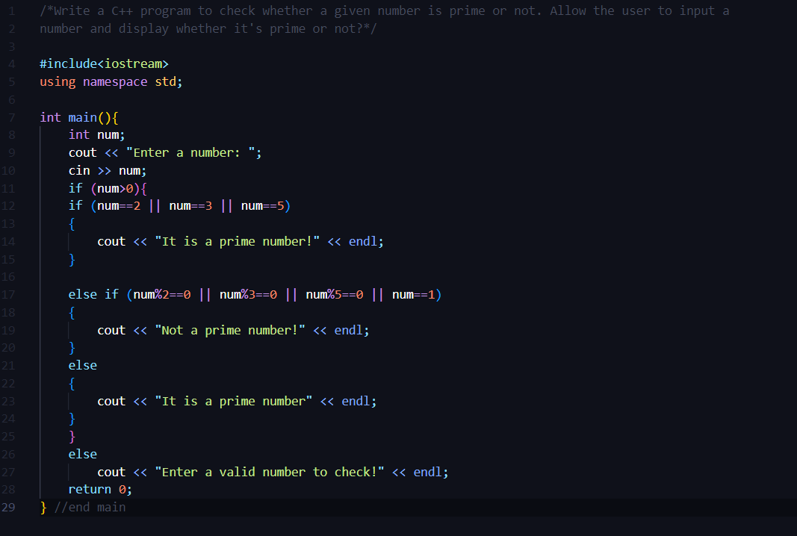

OUTPUT:

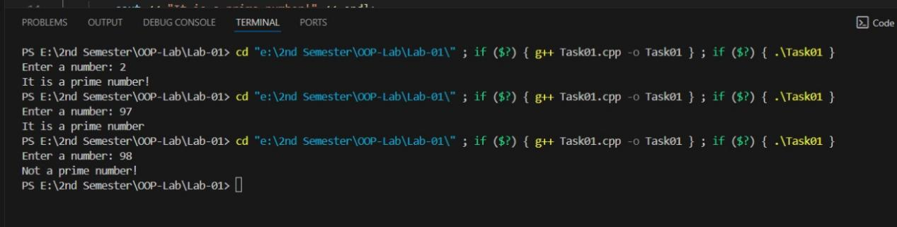

Question #2:

/*Create a C++ program to handle student marks management. The program should allow users to

input marks for students in four courses: PF, OOP, DLD & ICT. It should then calculate the total

marks, average marks, and determine the grade for each student based on their average.

Use the following grading metrics:

90 or above: Grade A

80-89: Grade B

70-79: Grade C

60-69: Grade D

Below 60: Grade F*/

#include<iostream>

using namespace std;

int main(){

    int choice, storeMarks[4];

    float marks,avgMarks, totalMarks=0;

    do

    {

        cout << "********STUDENT MARKS MANGEMENT SYSTEM********" << endl;

        cout << "\n";

        cout << "1. PF Marks" << endl;

        cout << "2. OOP Marks" << endl;

        cout << "3. DLD Marks" << endl;

        cout << "4. ICT Marks" << endl;

        cout << "5. Exit" << endl;

        cout << "Please select from the menu, 5 to exit the menu" << endl;

        cin >> choice;

    switch (choice)

    {

    case 1:

        cout << "Enter the marks obtained in PF: ";

        cin >> marks;

        if (marks>0){

            totalMarks += marks;

        }

        else{

            cout << "Invalid marks!" << endl;

        }

        break;

    case 2:

        cout << "Enter the marks obtained in OOP: ";

        cin >> marks;

        if (marks>0){

            totalMarks += marks;

        }

        else{

            cout << "Invalid marks!" << endl;

        }

        break;

     case 3:

        cout << "Enter the marks obtained in DLD: ";

        cin >> marks;

        if (marks>0){

            totalMarks += marks;

        }

        else{

            cout << "Invalid marks!" << endl;

        }

        break;

     case 4:

        cout << "Enter the marks obtained in ICT: ";

        cin >> marks;

        if (marks>0){

            totalMarks += marks;

        }

        else{

            cout << "Invalid marks!" << endl;

        }

        break;

        case 5:

            cout << "Exiting the Menu..." << endl;

            break;

    default:

        cout << "Please select from the menu provided!" << endl;

        break;

    }

    }

    while (choice!=5);

    cout << "Total Marks (out of 400) are: " << totalMarks << endl;

    avgMarks = totalMarks / 4;

   if (avgMarks>=90 && avgMarks<=100)

   {

       cout << "You achieved A grade" << endl;

   }

   else if (avgMarks>=80 && avgMarks<=89)

   {

    cout << "You achieved B grade" << endl;

   }

   else if (avgMarks>=70 && avgMarks<=79)

   {

    cout << "You achieved C grade" << endl;

   }

   else if (avgMarks>=60 && avgMarks<=69)

   {

    cout << "You achieved D grade" << endl;

   }

   else

   {

       cout << "You Failed, F grade" << endl;

   }

}

OUTPUT: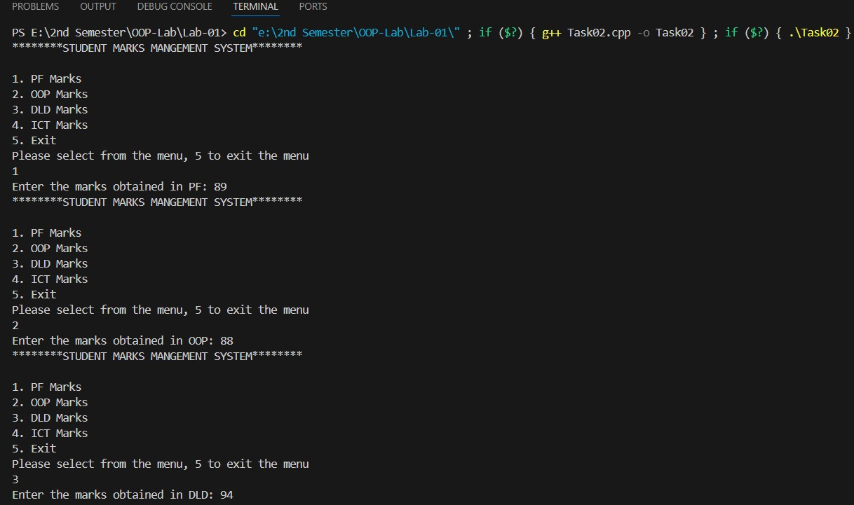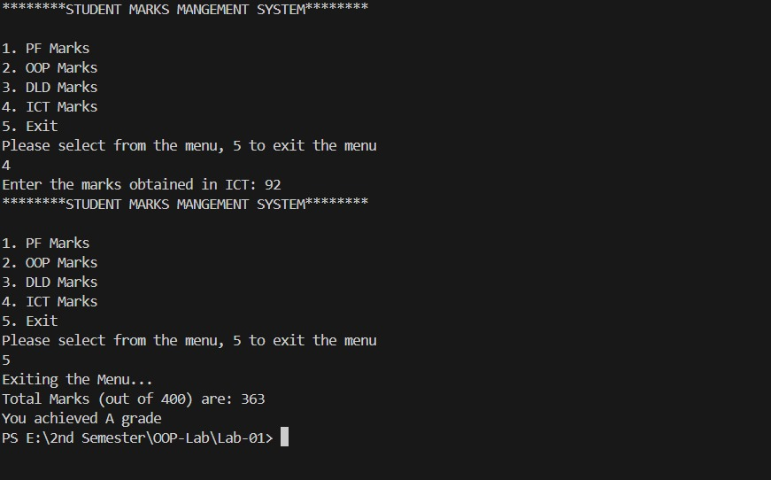

Question #4:

/*Write a program to take an integer array as an input from user and count all the even and odd

numbers in that list and print the counts.*/

#include<iostream>

using namespace std;

int main(){

    int size, evenCount=0, oddCount=0;

    cout << "Enter the size of the array: ";

    cin >> size;

    int array[size];

    cout << "Enter the elements of an array: ";

    for (int i = 0; i < size; i++)

    {

        cin >> array[i];

    }

    for (int i = 0; i < size; i++)

    {

        if (array[i]%2==0)

        {

            evenCount++; //even numbers counter

        }

        else if (array[i]%2!=0)

        {

            oddCount++; //odd numbers counter

        }

        else

        {

            continue;

        }

    }

    // cout << "Original Array: " << endl;

    // for (int i = 0; i < size; i++)

    // {

    //     cout << array[i] << ", ";

    // }

    cout << endl;

    cout << "Total even numbers in the arrays: " << evenCount << endl;

    cout << "Total odd numbers in the arrays: " << oddCount << endl;

    return 0;

}

OUTPUT:

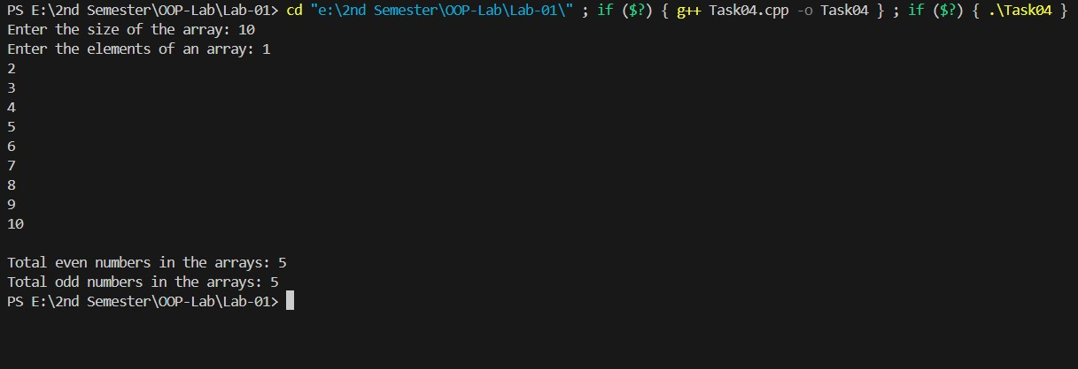

Question #5:

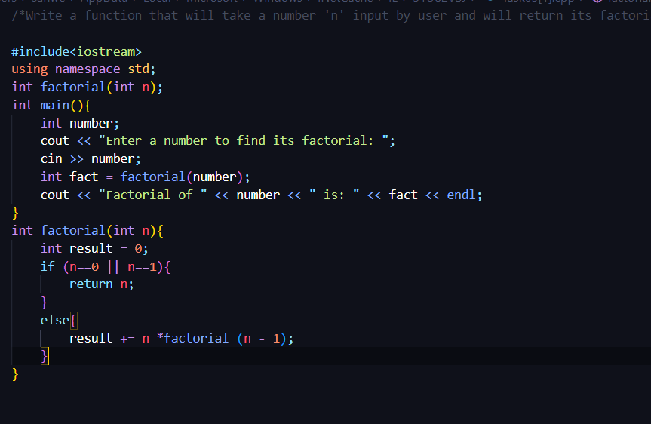

OUTPUT:

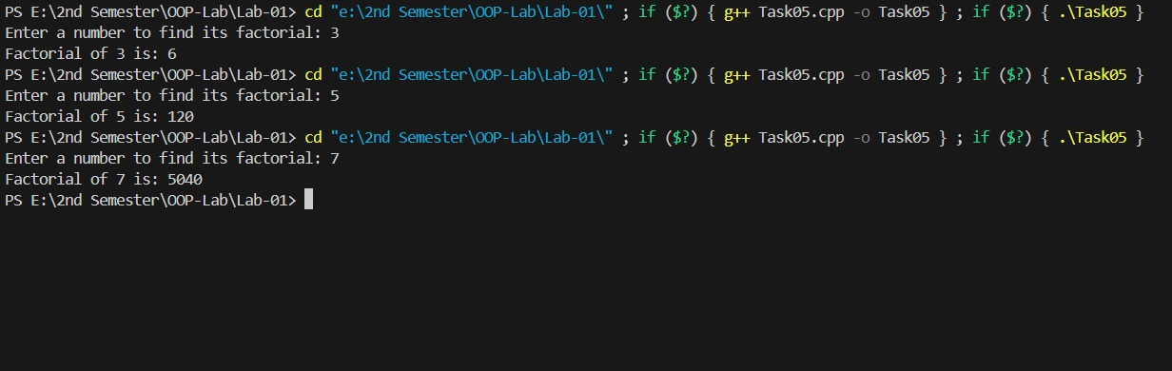

Question #7:

/*You are hired as a billing manager at K-Electric. Your task is to calculate the monthly bill

according to the units consumed. Write a program to input electricity unit charge and calculate the

total electricity bill according to the given condition:

For first 50 units Rs. 0.50/unit

For next 100 units Rs. 0.75/unit

For next 100 units Rs. 1.20/unit

For unit above 250 Rs. 1.50/unit

An additional surcharge of 20% is added to the bill.*/

#include<iostream>

using namespace std;

int main(){

    int unitConsumed;

    float billAmount, surcharge;

    cout << "Enter the number of units consumed: ";

    cin >> unitConsumed;

    if (unitConsumed>0)

    {

    if (unitConsumed<=50)

    {

        billAmount = unitConsumed * 0.50;

    }

    else if (unitConsumed>50 && unitConsumed<=150)

    {

        billAmount = 50 * 0.50 + (unitConsumed - 50) * 0.75;

    }

    else if (unitConsumed>150 && unitConsumed<=250)

    {

        billAmount = 50 * 0.50 + 100 * 0.75 + (unitConsumed - 150) * 1.20;

    }

    else

    {

        billAmount = 50 * 0.50 + 100 * 0.75 + 100 * 1.20 + (unitConsumed - 250) * 1.50;

    }

    surcharge = billAmount * 0.20;

    billAmount += surcharge;

    cout << "Total Electricity bill (including surcharges): Rs. " << billAmount;

    }

    else

    {

        cout << "Please Enter valid number of units";

    }

    return 0;

} /*P.S: was nicely confused before finding out the logic, but after noticing sample output cracked it. Easy but tricky */

OUTPUT:

